**Name:** Izza

**SAP ID:** 49360

**LAB TASK**

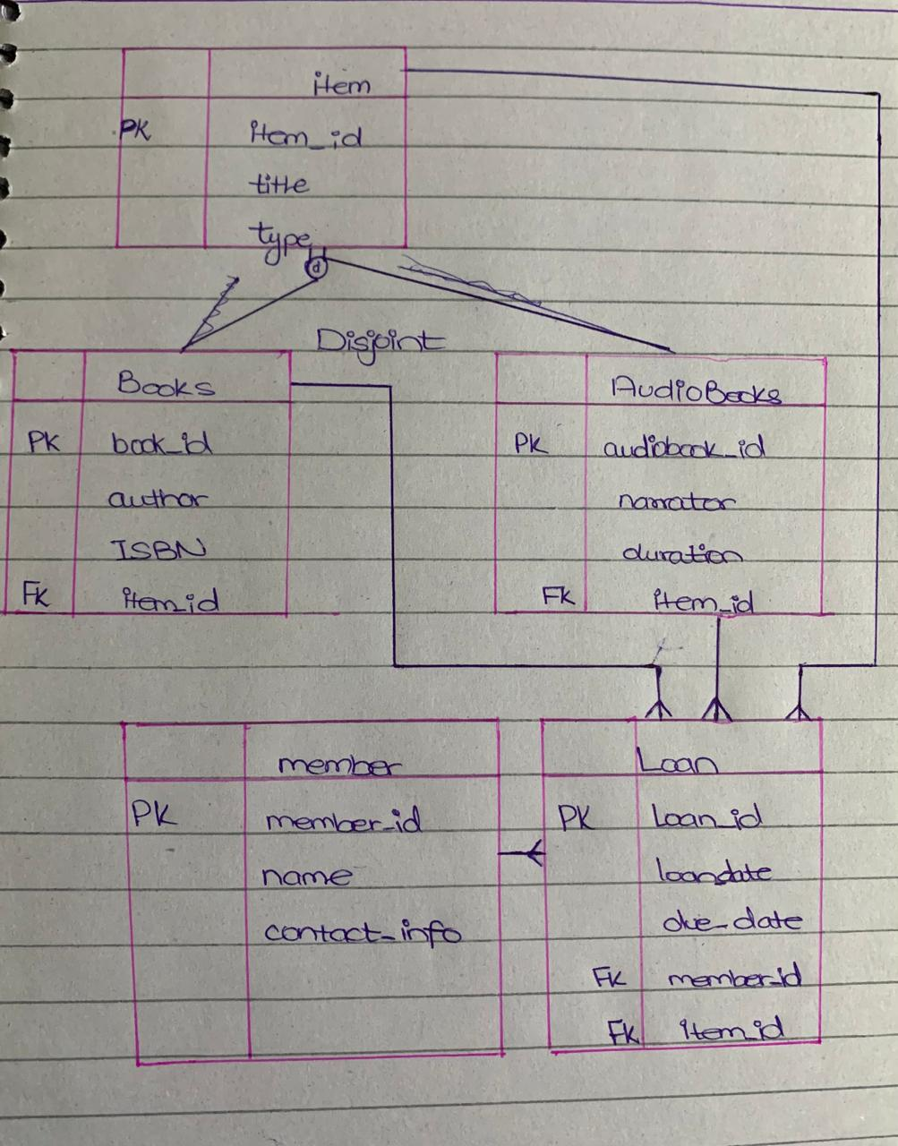

**SQL CODE:**

CREATE TABLE item (

item_id INT PRIMARY KEY,

title VARCHAR(50) NOT NULL

type VARCHAR(50) NOT NULL

);

CREATE TABLE Books (

book_id INT PRIMARY KEY,

item_id INT,

author VARCHAR(50) NOT NULL,

isbn VARCHAR(20) NOT NULL,

FOREIGN KEY (item_id) REFERENCES item(item_id)

);

CREATE TABLE Audiobooks (

audiobook_id INT PRIMARY KEY,

item_id INT,

narrator VARCHAR(255) NOT NULL,

duration INT NOT NULL,

FOREIGN KEY (item_id) REFERENCES item(item_id)

);

CREATE TABLE Member (

member_id INT PRIMARY KEY,

name VARCHAR(255) NOT NULL,

contact_info VARCHAR(255) NOT NULL

);

CREATE TABLE Loan (

loan_id INT PRIMARY KEY,

loan_date DATE NOT NULL,

due_date DATE NOT NULL,

member_id INT,

item_id INT,

FOREIGN KEY (member_id) REFERENCES Member(member_id),

FOREIGN KEY (item_id) REFERENCES item(item_id)

);